Private vs Public IP
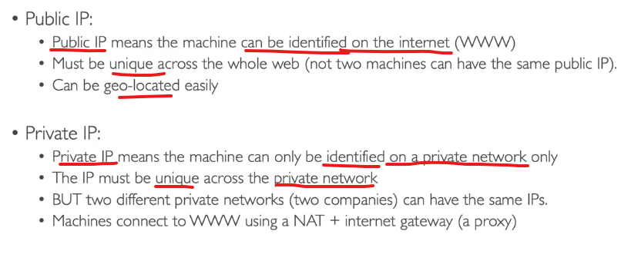
Elastic IP

